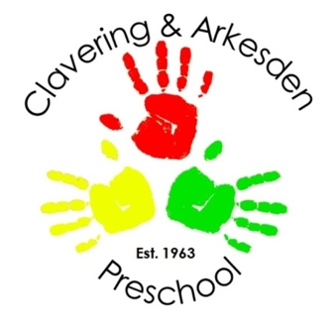

CONSUMABLES FORM SEPT 2025
PLEASE RETURN TO KELLIE finance@claveringarkesdenpreschool.co.uk
OR TO KELLIE/LAURA IN THE OFFICE

CHILD NAME ____________________________________________________

Please tick all that apply:
OTHER PRESCHOOL FEES | YES | NO
LUNCHES - £3.10 per day
Payment via Scopay
MORNING SNACK £2 per week
Invoiced half-termly in advance
VOLUNTARY CONTRIBUTION £25 per term
Invoiced once per term

Further Information:
Lunches: This will be a range of healthy hot dinners and desserts provided by Clavering Primary School. Menus are available to view on the Clavering Primary School website. Those who do not wish to opt into the lunches provided will need to continue to send their child in with a healthy (nut free) packed lunch in a labelled lunch box.
Snack: This will include a range of fresh fruit, yoghurt, cheese, crackers, raisins, croissants and vegetable sticks. It will also include a cultural or themed snack when occasions arise. If you choose to opt out then you must continue providing your child with a healthy (nut free) snack each day in a separate labelled snack box. If your child does not bring a snack to preschool, we will provide a snack for which you will be charged.
Voluntary contribution: This is a termly contribution which we ask for from parents to put towards experiment ingredients and equipment, cooking, celebrations and events to enable us to enjoy these activities with the children, together with extra nappies, wipes and suncream. As you may know the preschool is a charity, and without these contributions, we would be unable to purchase many of these items or enjoy as many activities with the children.
THERE MAY ALSO BE AD HOC FEES FOR TRIPS AND ACTIVITIES, THESE WILL BE INVOICED ACCORDINGLY FOLLOWING INFORMATION AND ACCEPTANCE TO ATTEND

SIGNED_____________________________ PARENT NAME _____________________________

